**Balaji K**

**Phone:** +91-9487046716

**Email:** [krishbala49@gmail.com](mailto:abishekgurumurthy@gmail.com)

4, Kannan Avenue Main Road, Old Perungalathur, Chennai- 63.

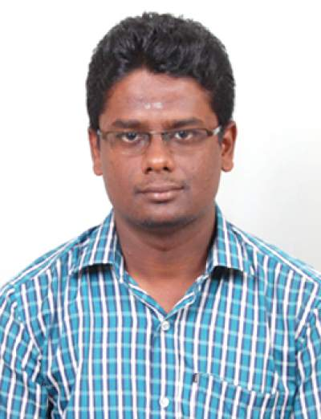



# Experience

**Design Engineer - Trainee |** JUNE 2019 - Present

*Makeorbuy Contracting pvt. ltd., Peenya, Bengaluru*

* **COMPOSITE BEAM DEVELOPMENT**
* Worked as a part of Research and Development team for developing a new economical and low depth composite beam section.
* Learnt the design of composite beams and the impact of each element in design aspect.
* Studied the basis in which moment – load interaction curves are formed in SP-16, as a part of composite beam development.
* **PHOENIX – EQUINOX**
* Equinox is a 30 storey Steel structure, situated near Hyderabad. It is an office building consisting of 4 towers.
* Understood the necessity of **automation** and developed an AutoCad script file for the fabrication drawings of columns in such a way that only entering the column ID will generate its fabrication drawing.
* Learnt the importance of **planning** and improved my **leadership skill** by heading a detailing team of 7 members and released drawings faster by proper planning and motivation, under pressure.
* Carried out reviewing and **checking of fabrication drawings**.
* **PHOENIX – 285**
* Phoenix -285, Hyderabad is an office building having 16 storeys. Designed **connections** for very few members as a training activity.
* **PETRAPOLE AIRPORT**
* Petrapole is an airport project in West Bengal. Designed passenger entrance canopies in enquiry stage using STAAD PRO.
* **PANCHSHIL**
* Panchsil is a high rise office building with 12 storeys, located in Pune. Designed the entire building using ETABS in enquiry stage.

# Education

**Master of Engineering |** June 2017 - May 2019

*MEPCO Schlenk Engineering College, Sivakasi*.

Stream: Structural Engineering | CGPA: **8.75**

**Bachelor of Engineering |** June 2013 - May 2017

*Sri Sairam Engineering College, Chennai*

Stream: Civil Engineering | CGPA: **8.46**

**Higher Secondary |** June 2012 - April 2013

*S.R.G.D.S. Matriculation Higher Secondary School, Thiruvannamalai.*

Major: Biology | Percentage: **92.92%**

**Secondary |** June 2010 - April 2011

*S.R.G.D.S. Matriculation Higher Secondary School, Thiruvannamalai.*

Board: Matriculation | Percentage: **94.2%**

# Languages

* English - Professional working level proficiency.
* Tamil - Native level proficiency.
* Telugu - Limited proficiency.

# Abilities

* ETABS
* STAAD PRO
* AUTOCAD
* SCRIPT

# Areas of Interest

* Steel Structures Design.
* Structural Automation.
* Composite Design.

# Internship

**CHENNAI METRO RAIL LTD.**

* The design and detailing of various components of metro stations are studied at a very shallow level.
* Studied the Structural and Architectural drawings of metro stations.

# Accomplishment

* Won **Best Paper award** in International Conference on Innovations in Engineering, Science and Technology 2019 (ICIEST 2019).
* Participated in International Conference, “Industry 4.0 and Advancements in Civil Engineering” held at PSG Institute of Technology and Applied Research.
* Published a journal on “Development of brick as a Thermal and acoustic resistant building component” in International Journal of Engineering Research and Applications.

# References

* Haridoss B,

Design Engineer,

Geodesic techniques pvt. ltd.

Contact No.: 9750423653.

* Naveen B,

Design Engineer,

Makeorbuy Contracting pvt. ltd.

Contact No.: 8903043535.